**Design Documentation**

**Architectural Design**

**Full Body**

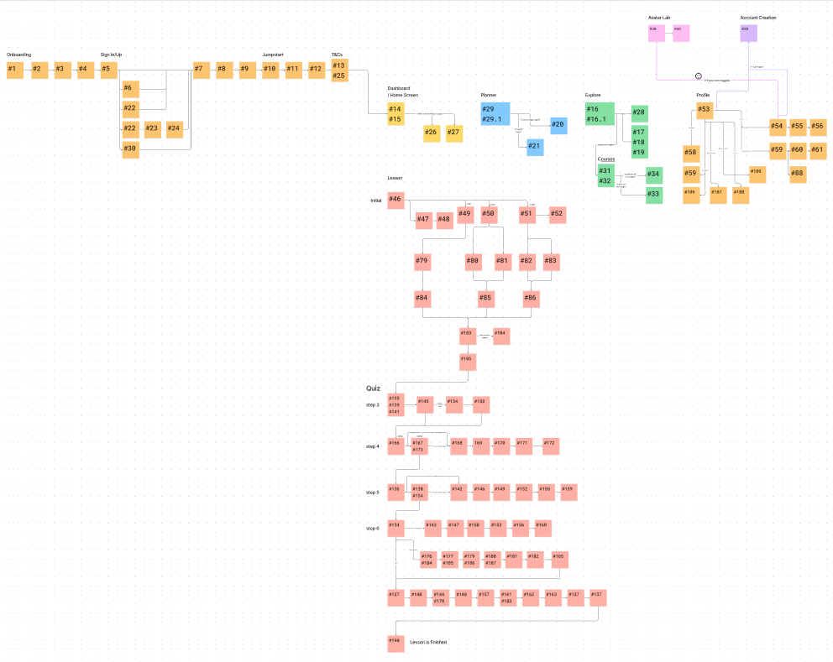

**Jumpstart**

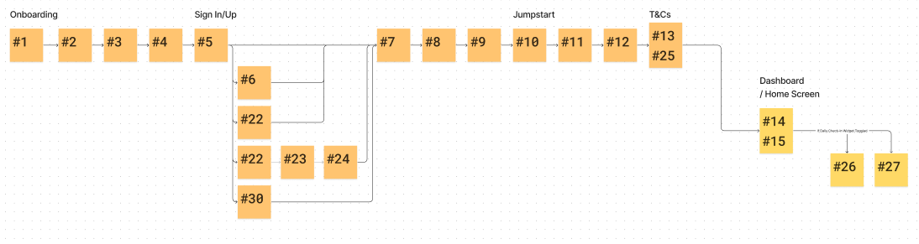

**Planner**

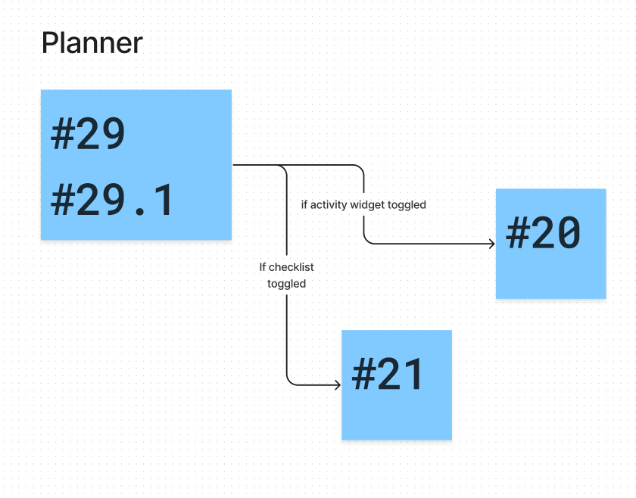

**Explore**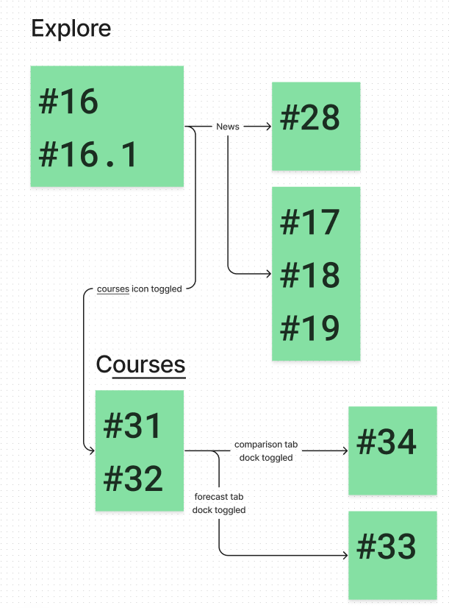

**Profile**

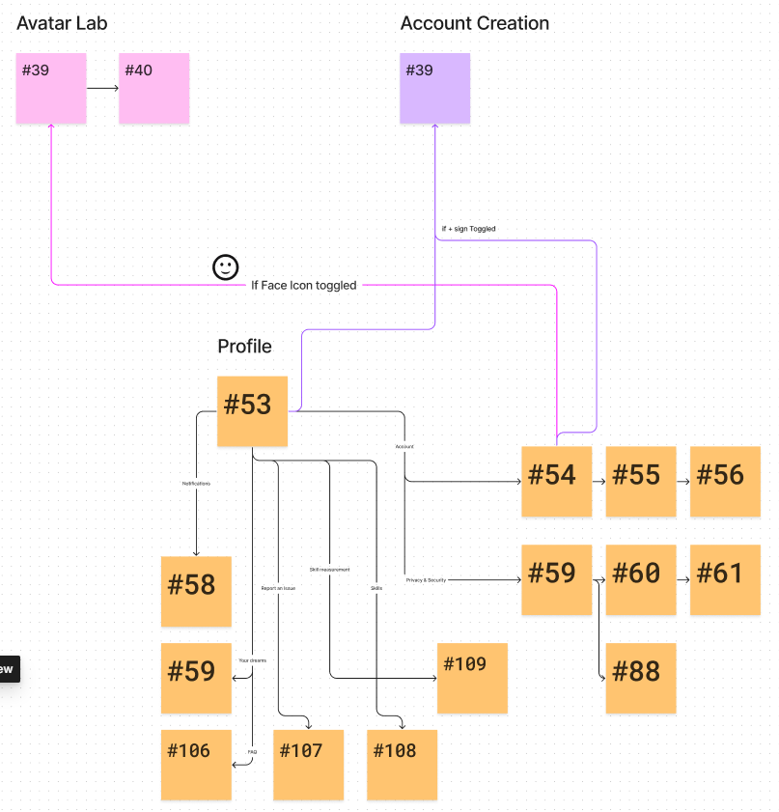

**Lesson**

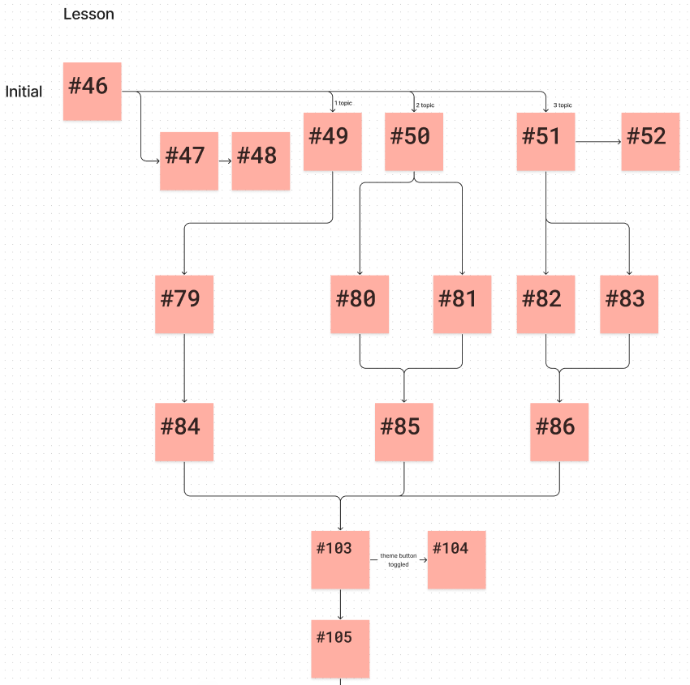

**Quiz**

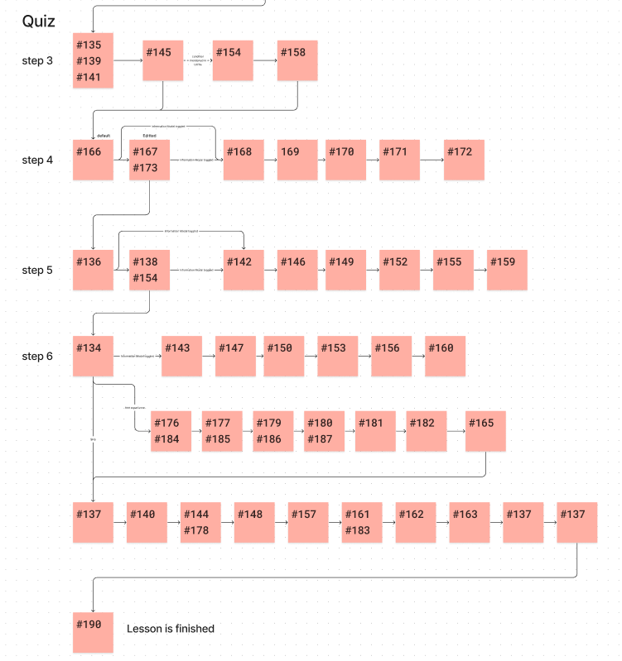

**Detailed Design**

|  |  |  |  |  |  |
| --- | --- | --- | --- | --- | --- |
| **Req. ID** | **Requirement Description** | **Justification** | **Data Structures** | **Dependencies for Swift/Android Development** | **Test Result** |
| RQ1 | User can create a new account | Enable users to access personalized content | User database | Swift: Authentication Framework  Android: Authentication Library | Pass |
| RQ2 | User can log in to the system | Secure access to user-specific information | Authentication | Swift: Authentication Framework  Android: Authentication Library | Pass |
| RQ6 | User receives notifications | Stay informed about interactions and updates | Notification system | Swift/Android: Push Notification Service | Pass |
| RQ7 | User can edit their profile | Personalize and update user information | User profile data | Swift/Android: User Interface Library | Pass |
| RQ8 | User can delete their account | Provide an option to permanently remove account | User database | Swift/Android: Account Management Library | Pass |
| RQ9 | User can start a course | Begin educational programs | Course information | Swift/Android: Educational Content Library | Pass |
| RQ10 | User can complete a programming level | Demonstrate proficiency in programming skills | Progress tracking | Swift/Android: Progress Tracking Library | Pass |
| RQ11 | User can complete an assignment | Mark assignment as completed or not completed | Assignment data | Swift/Android: Assignment Management Library | Pass |
| RQ12 | User can choose another course | Explore different educational options | Course selection data | Swift/Android: Course Selection Library | Pass |
| RQ13 | User can access coding exercises | Practice coding skills through exercises | Coding exercise data | Swift/Android: Coding Exercise Library | Pass |
| RQ14 | User can view code solutions | Learn from example solutions to coding exercises | Solution database | Swift/Android: Coding Exercise Library | Pass |
| RQ16 | User can view progress analytics | Track and analyze personal progress in programming | Analytics data | Swift/Android: Analytics Library | Pass |
| RQ17 | User can access video lectures | Learn through video-based educational content | Video lecture data | Swift/Android: Video Streaming Library | Pass |
| RQ18 | User can download course materials | Access educational materials offline | Downloadable files | Swift/Android: Download Manager Library | Pass |
| RQ19 | User can receive real-time coding feedback | Get immediate feedback on coding exercises | Feedback engine | Swift/Android: Real-time Feedback Library | Pass |
| RQ20 | User can share achievements on social media | Share progress and accomplishments on social platforms | Social media integration | Swift/Android: Social Media API | Pass |
| RQ22 | User can bookmark favorite coding challenges | Save and revisit preferred coding challenges | Bookmarking system | Swift/Android: Bookmarking Library | Pass |
| RQ23 | User can access coding tutorials | Learn programming concepts through step-by-step guides | Tutorial data | Swift/Android: Tutorial Presentation Library | Pass |
| RQ24 | User can customize coding environment | Adapt the coding environment to personal preferences | Customization settings | Swift/Android: User Interface Library | Pass |
| RQ25 | User can earn virtual badges | Receive badges for completing challenges and milestones | Badge system | Swift/Android: Badge Management Library | Pass |
| RQ28 | User can export progress data | Save and analyze personal progress data | Export feature | Swift/Android: Data Export Library | Pass |
| RQ29 | User can set coding goals | Establish and track individual coding objectives | Goal-setting features | Swift/Android: Goal-setting Library | Pass |
| RQ30 | User can provide feedback on course content | Contribute input to improve the quality of course material | Feedback system | Swift/Android: Feedback Management Library | Pass |
| RQ31 | Admin can create a new course | Add new courses to the platform | Course management | Swift/Android: Course Management Library | Pass |
| RQ32 | Admin can edit existing course details | Modify information about existing courses | Course management | Swift/Android: Course Management Library | Pass |
| RQ33 | Admin can delete a course | Remove outdated or irrelevant courses | Course management | Swift/Android: Course Management Library | Pass |
| RQ34 | Admin can create a new exam | Add new exams to the platform | Exam management | Swift/Android: Exam Management Library | Pass |
| RQ35 | Admin can edit existing exam details | Modify information about existing exams | Exam management | Swift/Android: Exam Management Library | Pass |
| RQ36 | Admin can delete an exam | Remove outdated or irrelevant exams | Exam management | Swift/Android: Exam Management Library | Pass |

**Database Design**

*go to database architecture.pdf*